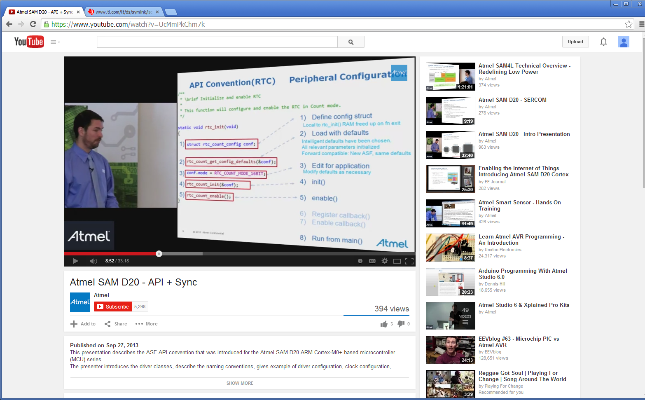

Step binds a software instance. A specific function name associated with the software instance.

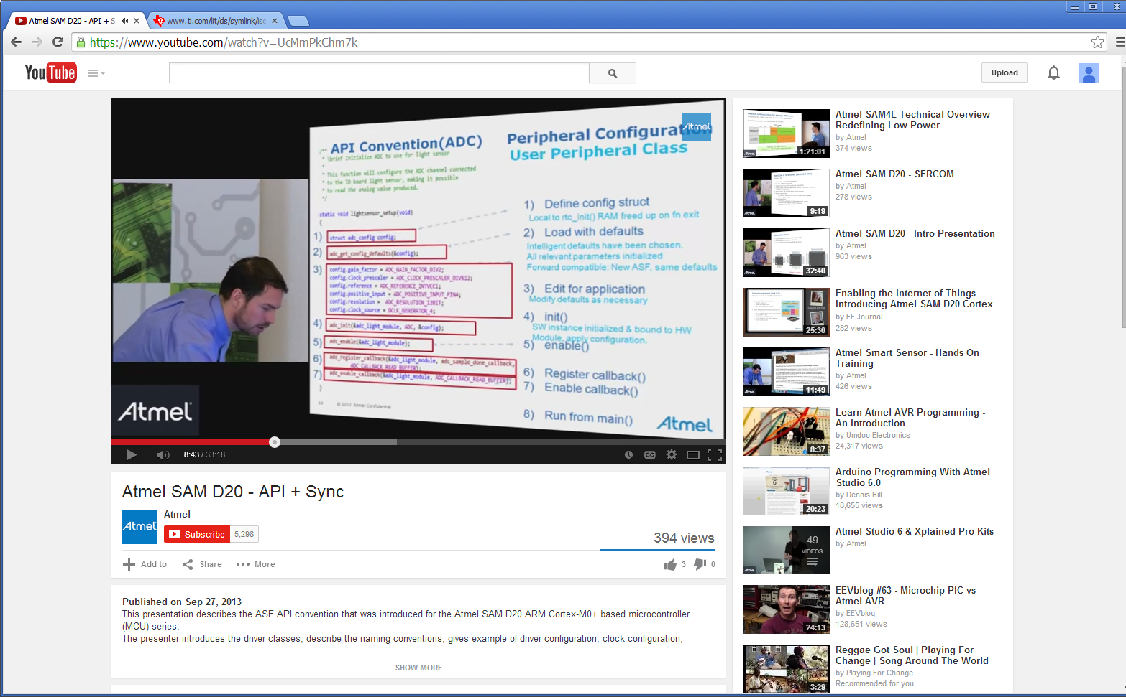

The word instance should be understood to mean “copy”

First start and load working defaults. Then overwrite only values needed for your instance.

ALT-D on enum values in the config structure shows the possible values from the .h file.

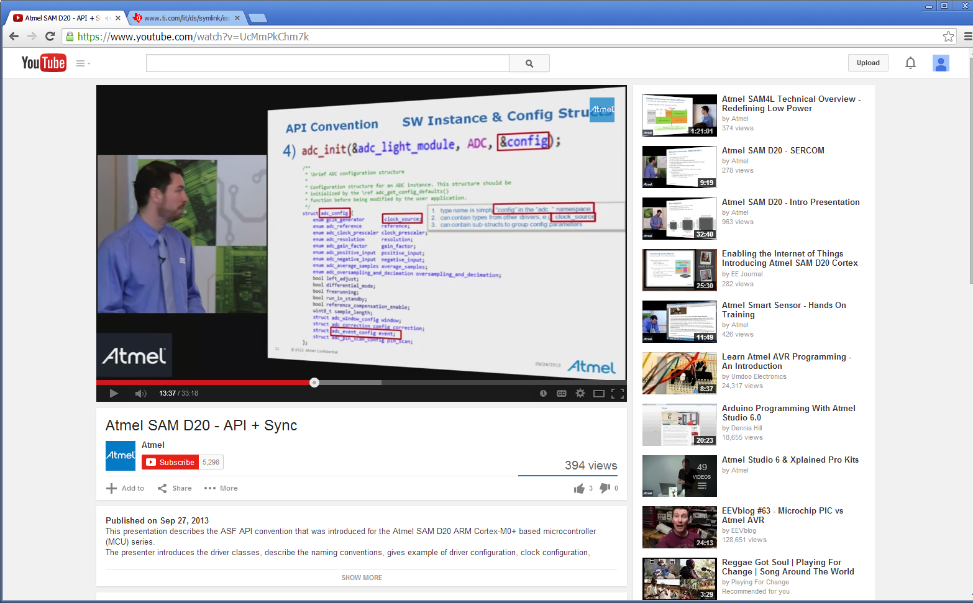

Software instance, copy…, &adc_light_module

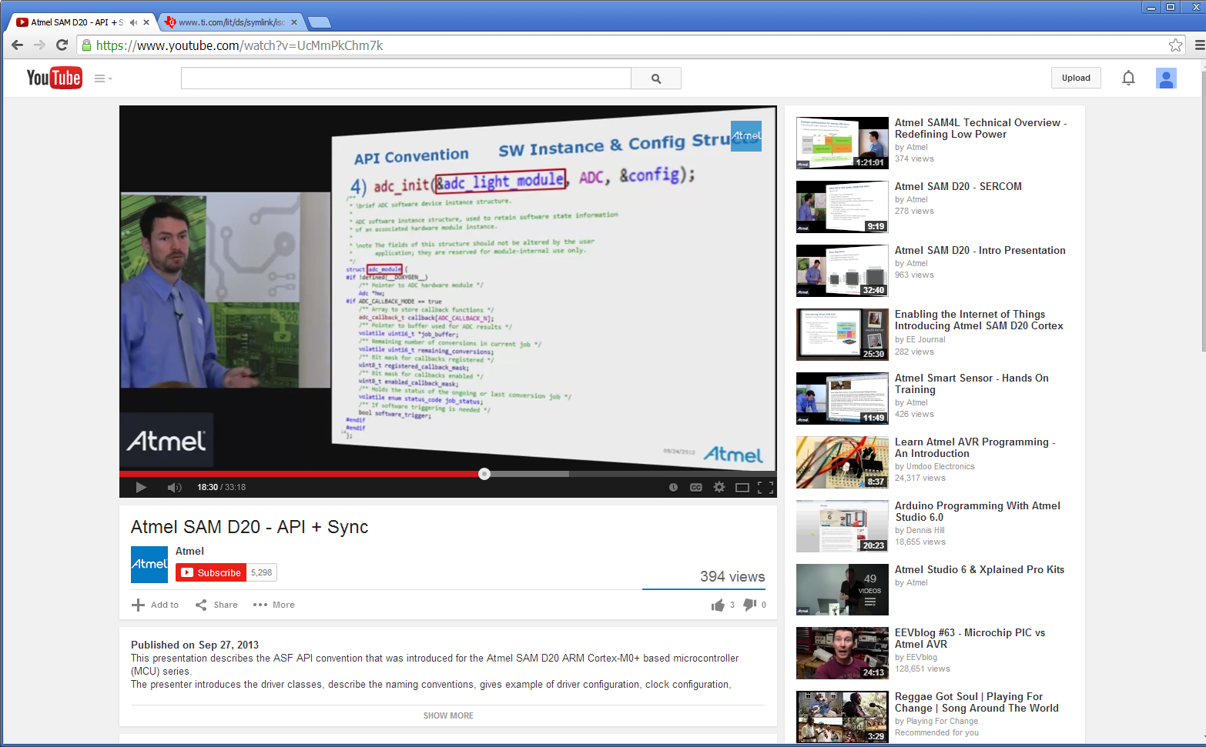

How to handle these structures and where they should be stored…

The instance structure must be global but config structure must be in the init routine so it get thrown away when the initialization is completed. The config structure exist so it can be manipulated/modified in the init routine and then it gets used to fill in all the hardware values. Once the hardware is initialized, the config structure is no longer needed.

The ADC_Module… The instance structure describes read/write buffer sizes, names, functions, call back functions etc. Things that one will use to interface with the hardware. The hardware’s driver/api list.

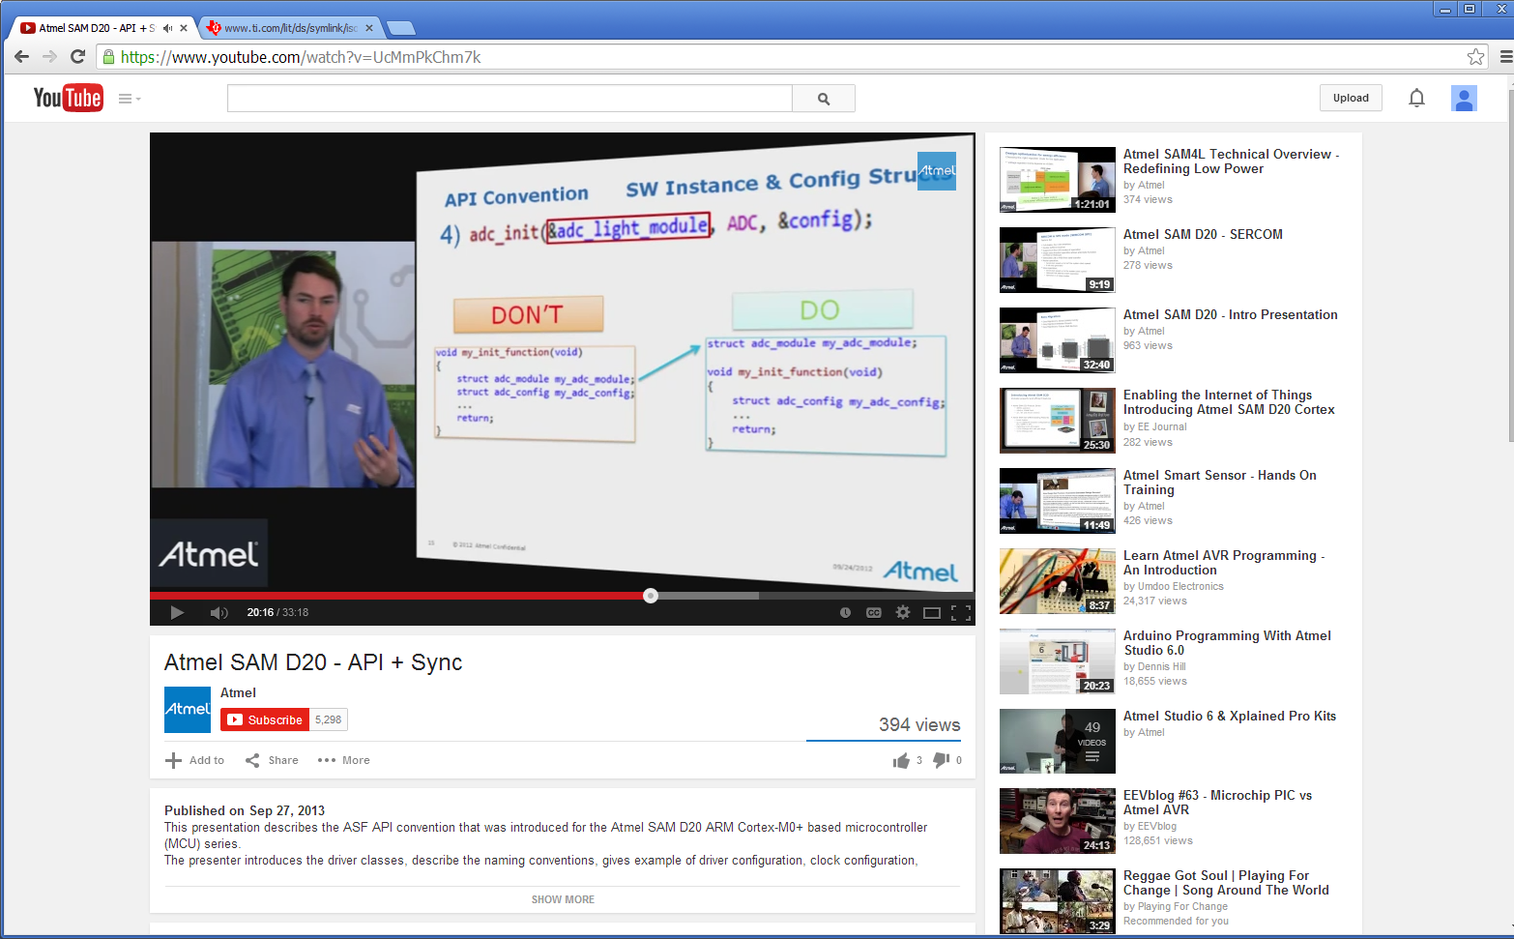

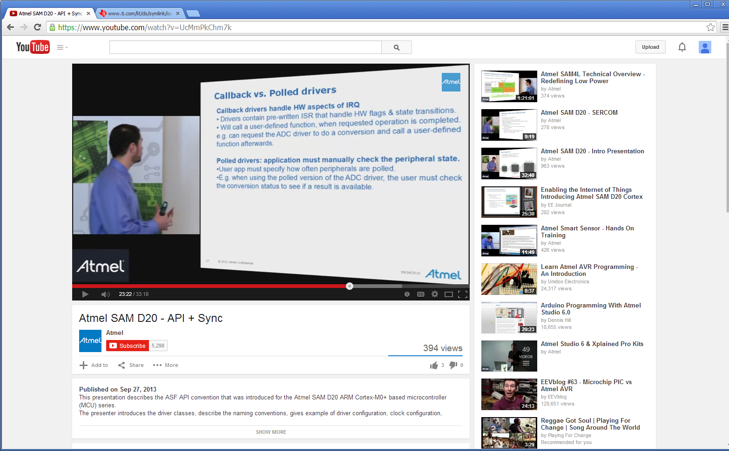

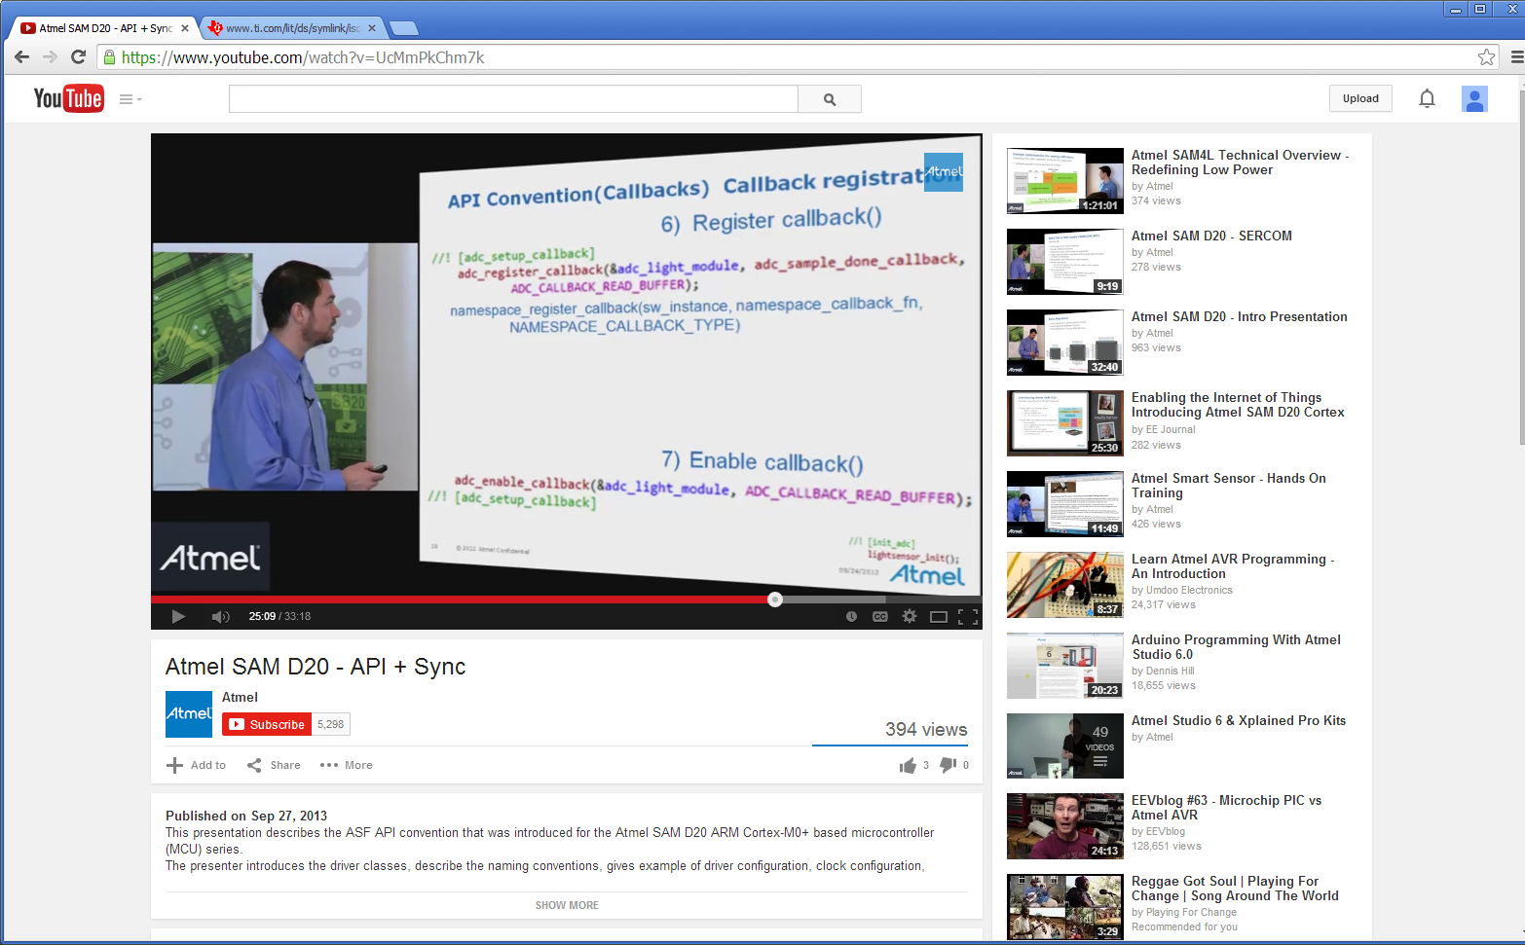

ALT-G on call back will show the parameters

